# **Lab 4**

Author: Qadeer Hussain

Student ID: C00270632

Table of Contents

**Lab 4** 1

**Getting Started** 2

**Install Istio** 2

**Install the Kubernetes Gateway API CRDs** 2

**Deploy the sample application** 2

**Open the application to outside traffic** 3

**Access the application** 3

**View the dashboard** 4

## **Getting Started**

Download ZIP from git repo and add to the environment variables.

## **Install Istio**

## **Install the Kubernetes Gateway API CRDs**





## **Deploy the sample application**





## **Open the application to outside traffic**

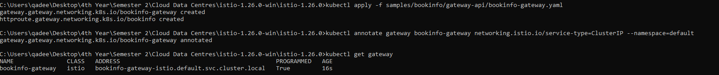

## **Access the application**



## **View the dashboard**

